Agentic Test Automation

Overview
- d overall productivity by up to 60%.
Transform testing with Agentic AI. Fully embedded in Tosca, it creates complete test cases from natural language. Industry-first enterprise agentic AI.
- Autonomous test creation:Generates test cases for Projects through agentic AI and natural language prompts.
- AI-driven efficiency:Reduces manual human effort for test case authoring.
- Integration:Works seamlessly with existing workflow.
- Time savings:Reduce in manual efforts for initial test case creation

Workflow

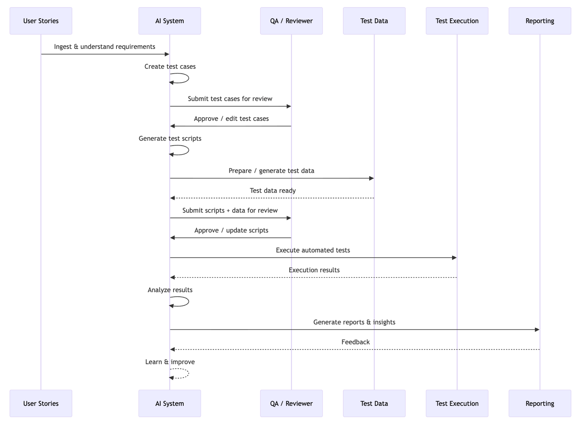
The process starts with user stories, which the AI analyzes to automatically generate test cases. These are reviewed and approved by QA. Once approved, the AI creates automated test scripts and prepares the necessary test data, which are again validated by QA.
After approval, the AI triggers automated test execution. The execution results are returned to the AI, which analyzes them and generates reports and insights.
Finally, feedback from reporting is fed back into the AI system, enabling continuous learning and improvement.

Functional Requirements Document

User Story Ingestion & Understanding
Purpose
Transform business requirements into structured, testable artifacts.
Inputs
· User stories
· Acceptance criteria
· Requirement documents
Outputs
· Parsed requirements
· Identified test scenarios
· Traceable requirement objects
How AI helps
· Applies natural language understanding to interpret user stories
· Extracts functional intent and acceptance criteria automatically
· Infers implicit scenarios such as edge cases and negative paths
· Flags ambiguities, missing details, or conflicting requirements

Test Case Creation
Purpose
Generate comprehensive and consistent test coverage.
Inputs
· Parsed requirements
· Historical testing knowledge
Outputs
· Structured test cases
· Preconditions, steps, expected results
· Test priority and type
How AI helps
· Automatically derives test cases from requirements
· Expands coverage beyond explicitly stated scenarios
· Standardizes test case structure and naming
· Prioritizes tests based on risk and impact

Test Case Review & Management
Purpose
Ensure correctness and governance of test cases.
Inputs
· AI-generated test cases
· User feedback and edits
Outputs
· Approved and versioned test cases
· Audit history
How AI helps
· Highlights changes between versions for faster review
· Suggests improvements based on best practices
· Learns from user edits and approval decisions
· Reduces review effort by improving first-pass quality

Test Script Creation
Purpose
Convert test cases into executable automation.
Inputs
· Approved test cases
· Automation framework configuration
Outputs
· Executable test scripts
· Reusable components
How AI helps
· Translates test steps into automation code
· Identifies reusable flows and shared components
· Adapts generated scripts to different frameworks
· Automatically updates scripts when test cases change

Test Script Review & Management
Purpose
Maintain quality and reliability of automation code.
Inputs
· AI-generated scripts
· User modifications
Outputs
· Approved automation scripts
· Versioned artifacts
How AI helps
· Performs static analysis on generated scripts
· Suggests refactoring for maintainability
· Detects duplicated or brittle automation logic
· Learns preferred coding patterns from reviewers

Test Execution
Purpose
Validate application behavior through automated testing.
Inputs
· Approved scripts
· Target environments
Outputs
· Execution results
· Logs and artifacts
How AI helps
· Optimizes execution order and parallelization
· Selects relevant tests based on recent changes
· Dynamically adjusts retries for flaky tests
· Monitors execution anomalies in real time

Result Analysis
Purpose
Reduce manual triage and speed up defect identification.
Inputs
· Raw execution results
· Historical execution data
Outputs
· Failure classification
· Root cause insights
How AI helps
· Classifies failures by likely root cause
· Identifies flaky or unstable tests
· Correlates failures with recent code or requirement changes
· Suggests probable defect locations

Reporting & Insights
Purpose
Provide visibility into quality and risk.
Inputs
· Execution results
· Traceability data
Outputs
· Reports and dashboards
· Quality insights
How AI helps
· Generates natural-language summaries of results
· Highlights trends and risk areas
· Answers ad-hoc quality questions conversationally
· Translates raw metrics into actionable insights

Continuous Learning & Feedback Loop
Purpose
Improve system accuracy over time.
Inputs
· User feedback
· Execution outcomes
Outputs
· Improved test artifacts
· Reduced noise and redundancy
How AI helps
· Learns from approvals, edits, and rejections
· Refines test generation logic automatically
· Reduces repeated generation of low-value tests
· Adapts to evolving application behavior

First use case Datahub login

[Story]

As an unauthenticated user, I want to be prompted to login when I attempt to access the Submission Requests page.

[Requirements]

The "Submission Requests" page can only be accessed by authenticated users.
If the user clicks on the "Submission Requests" menu from the navigation bar before logging in, pop up a dialog box asking user to log in first.
The dialog box should display a message and 2 action buttons, Login and Close.
The message should say, "Please log in to access the CRDC Intake Questionnaires".
The Login button or login link will take the user to the NIH Login page.
Upon a successful login, the user will be taken to the "CRDC Intake Questionnaires" page to see their Questionnaires.
If the user clicks on the Close button, the dialog is closed and the user should stay where he/she was at (for now, CRDC Data Hub Home page).

Figma Design: https://www.figma.com/file/SsPDLFQUKKzaMY5gOylWn9/Submission-Request?type=design&node-id=2732-34419&mode=design&t=au91qBcn6OSmWjqC-4

UI Mock up

Reference

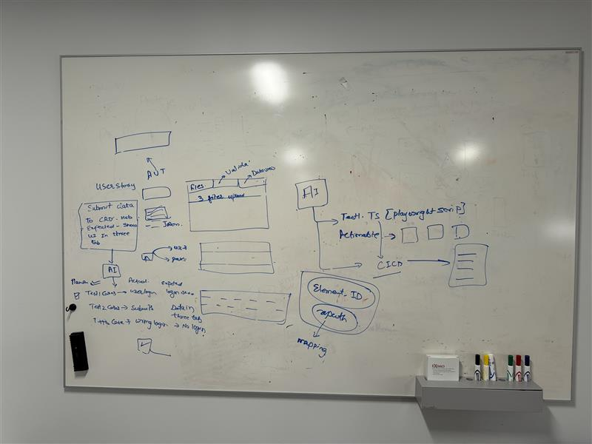

sequenceDiagram
participant BR as User Stories
participant AI as AI System
participant QA as QA / Reviewer
participant TD as Test Data
participant AUT as Test Execution
participant R as Reporting

BR->>AI: Ingest & understand requirements
AI->>AI: Create test cases
AI->>QA: Submit test cases for review
QA->>AI: Approve / edit test cases

AI->>AI: Generate test scripts
AI->>TD: Prepare / generate test data
TD-->>AI: Test data ready

AI->>QA: Submit scripts + data for review
QA->>AI: Approve / update scripts

AI->>AUT: Execute automated tests
AUT-->>AI: Execution results

AI->>AI: Analyze results
AI->>R: Generate reports & insights

R-->>AI: Feedback
AI-->>AI: Learn & improve

